Session tracking using HttpSession (Server side session tracking)

In Django, the sessions framework allows you to store and retrieve arbitrary data on a per-site-visitor basis. Since HTTP is stateless, sessions provide a way for the server to "remember" users between independent requests

How it Works
- Session ID: Django generates a unique, random string called a session key (or session ID) for each visitor.
- Cookies: This ID is sent to the user's browser as a cookie named sessionid by default.
- Data Storage: While the browser only holds the ID, the actual session data is stored securely on your server (usually in a database).
- Retrieval: On subsequent requests, the browser sends the cookie back. Django's middleware uses the ID to look up and populate the request.session attribute in your view

Session Storage Engines
You can choose where to store session data by setting SESSION_ENGINE in your settings.py
Database (Default): django.contrib.sessions.backends.db — Reliable and persistent.

Requirements to work with server side session tracking
Settings.py do the following configuration
- Install an application :

INSTALLED_APPS = [
'django.contrib.admin',
'django.contrib.auth',
'django.contrib.contenttypes',
'django.contrib.sessions',
'django.contrib.messages',
'django.contrib.staticfiles',

- Define the middleware

MIDDLEWARE = [
'django.middleware.security.SecurityMiddleware',
'django.contrib.sessions.middleware.SessionMiddleware',
'django.middleware.common.CommonMiddleware',
'django.middleware.csrf.CsrfViewMiddleware',
'django.contrib.auth.middleware.AuthenticationMiddleware',
'django.contrib.messages.middleware.MessageMiddleware',
'django.middleware.clickjacking.XFrameOptionsMiddleware',
]

- Define session engine, where to store session details

SESSION_ENGINE='django.contrib.sessions.backends.db'

django.contrib.sessions.backends.db (default)
django.contrib.sessions.backends.file
django.contrib.sessions.backends.cache

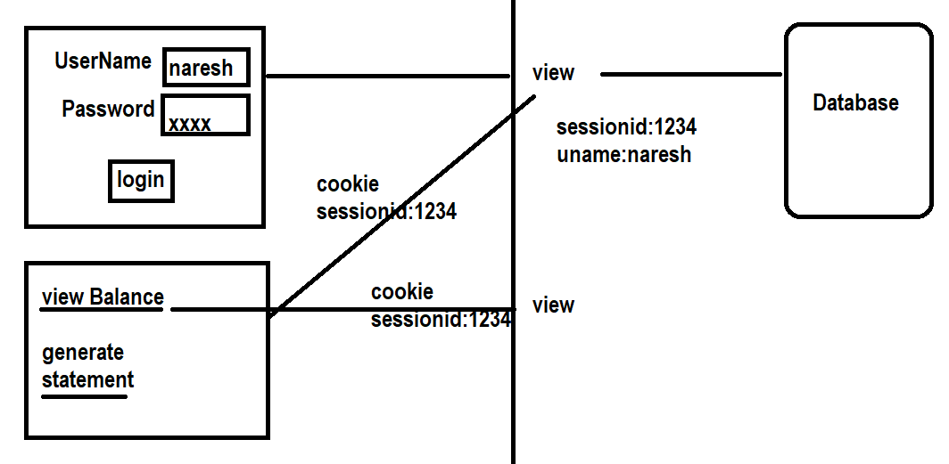
In Django, request.session is an attribute of the HttpRequest object that allows you to store and retrieve arbitrary data on a per-site-visitor basis

When a user visits your site, Django creates a unique session ID and sends it to the browser as a cookie (usually named sessionid). This ID is then used to map subsequent requests back to the specific session data stored on your server.

Accessing Data: Retrieve values using standard dictionary methods like request.session.get('key') or request.session['key'].

Storing Data: Assign values directly: request.session['key'] = 'value'.

Deleting Data: Use del request.session['key'] for specific keys or request.session.flush() to delete the entire session and its cookie

Create project
Create application within project

settings.py
INSTALLED_APPS = [
'django.contrib.admin',
'django.contrib.auth',
'django.contrib.contenttypes',
'django.contrib.sessions',
'django.contrib.messages',
'django.contrib.staticfiles',
'app'
]

MIDDLEWARE = [
'django.middleware.security.SecurityMiddleware',
'django.contrib.sessions.middleware.SessionMiddleware',
'django.middleware.common.CommonMiddleware',
'django.middleware.csrf.CsrfViewMiddleware',
'django.contrib.auth.middleware.AuthenticationMiddleware',
'django.contrib.messages.middleware.MessageMiddleware',
'django.middleware.clickjacking.XFrameOptionsMiddleware',
]

SESSION_ENGINE='django.contrib.sessions.backends.db'

PS D:\Backup\Django9amMar\project30> python manage.py makemigrations
No changes detected
PS D:\Backup\Django9amMar\project30> python manage.py migrate

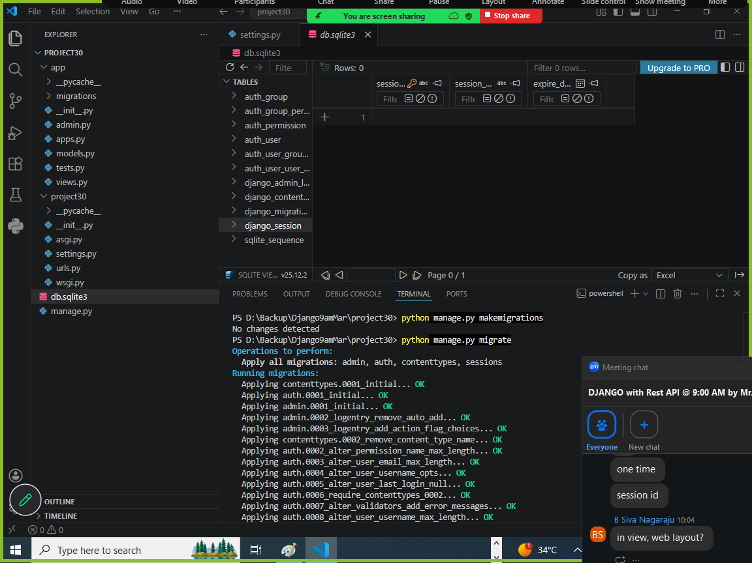

Session table is created with 3 columns
- session_key 🡪 primary key
- session_data
- expire_date

login.html
<!DOCTYPE html>
<html lang="en">
<head>
<meta charset="UTF-8">
<meta name="viewport" content="width=device-width, initial-scale=1.0">
<title>Document</title>
</head>
<body>
<form action="/login/" method="post">
{%csrf_token%}
<table border="2" width="100%">
<tr>
<td>UserName</td>
<td><input type="text" name="uname"></td>
</tr>
<tr>
<td>Password</td>
<td><input type="password" name="pwd"></td>
</tr>
<tr>
<td><input type="submit" value="login"></td>
<td><input type="reset" value="clear"></td>
</tr>
</table>
</form>
<h2>{{msg}}</h2>
</body>
</html>

details.html
<!DOCTYPE html>
<html lang="en">
<head>
<meta charset="UTF-8">
<meta name="viewport" content="width=device-width, initial-scale=1.0">
<title>Document</title>
</head>
<body>
<h2>
<a href="/view_bal">View Balance</a>
</h2>
<h2>Balance is {{balance}}</h2>
</body>
</html>

Urls.py
from django.contrib import admin
from django.urls import path
from app.views import login_view,view_balance

urlpatterns = [
path('admin/', admin.site.urls),
path('login/',login_view),
path('view_bal/',view_balance),
]

Views.py
from django.shortcuts import render

# Create your views here.
users={'naresh':'n123',
'ramesh':'r123',
'kishore':'k123'}

accounts={'naresh':45000,
'ramesh':50000,
'kishore':70000}

def login_view(request):
if request.method=="GET":
response=render(request,"login.html")
return response
else:
uname=request.POST.get('uname')
pwd=request.POST.get('pwd')
if uname in users and users[uname]==pwd:
request.session['uname']=uname
response=render(request,"details.html")
return response
else:
response=render(request,"login.html",context={'msg':"invalid username or password"})
return response

def view_balance(request):
uname=request.session['uname']
balance=accounts[uname]
response=render(request,"details.html",context={'balance':balance})
return response

settings.py
INSTALLED_APPS = [
'django.contrib.admin',
'django.contrib.auth',
'django.contrib.contenttypes',
'django.contrib.sessions',
'django.contrib.messages',
'django.contrib.staticfiles',
'app'
]

SESSION_ENGINE='django.contrib.sessions.backends.db'

